- Java identifiers are case sensitive
- pre-defined class can be used for Identifier
int Integer=10

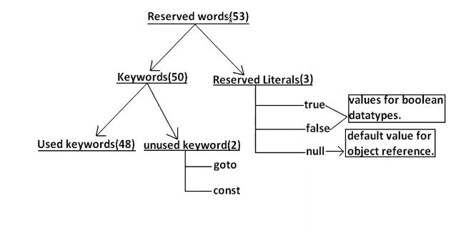

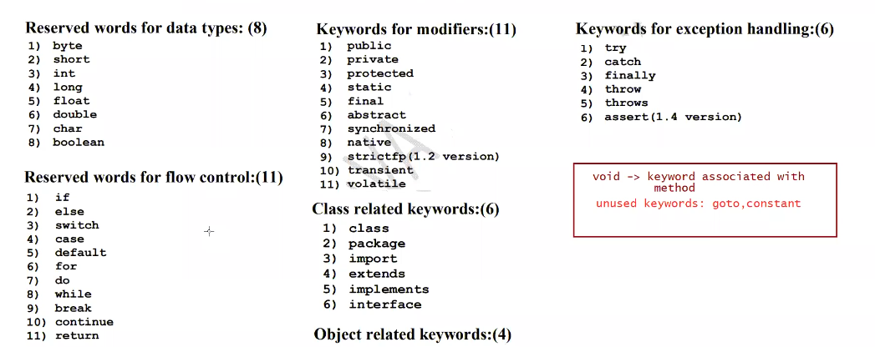
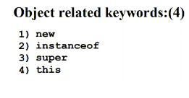

Java is strictly typed language : we need to tell the compiler what data type the variable will hold.

Literal : Any constant value that can be assigned to variable
int a=10
a--------------identifier
int----------------------Data Type
10-------------------------Literal

Reserved literals :
true
false
null
For boolean data-type reserved literals are true/false. Any value other than this would result in compile time error

Data Types:

Every variable has a type
Every Expression has a type.
Compiler Role : Compiler will check the value stored can be handled by data-type or not
This is called type-Cheking/Strictly type-Chekcing

int a=10
boolean result=true----Compiler will check whether the assigned variable can be stored in that data-type

Primitive Data types : Data which is commonly used and supported by any language to store directly.

a.Numeric Values
-----Real number
-----Whole number
b.Character Values
c.boolean values
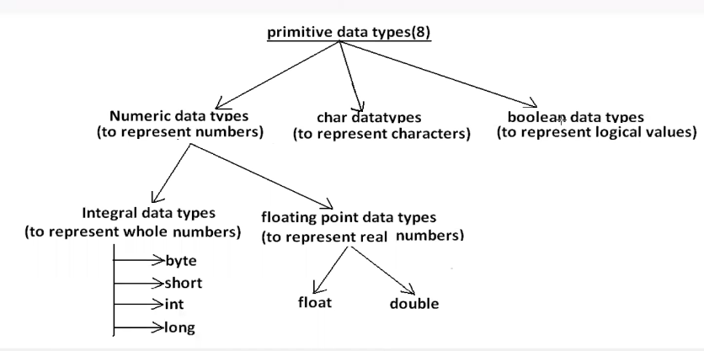

To store we have 4data-types
- byte
- short
- long
- int

size---How much memory is allocated to that data-type by JVM

Byte.SIZE----- We can know the size of Byte
Byte.MIN_VALUE ---Min Value that Byte can hold
Byte.MAX_VALUE ----Max Value that Byte datatype cna hold

byte a=25
byte b=135------------Compiler time error.

All reserved words start with lowercase.
Class/Interface names will start with Uppercase

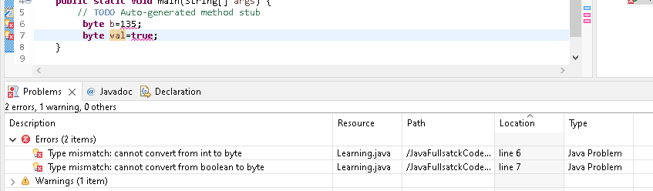
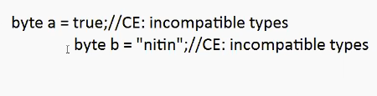

When to use byte data-type:
It is used when we handle the data which is coming from stream,network.

Short :
Short.SIZE ---- 2 BYTES
Short.MIN_VALUE ----- -32768
Short.MAX_VALUE ------ 32767

short data=137 –Valid
short data=32768

This data-type is not at all used and best suited for old processors like 8086
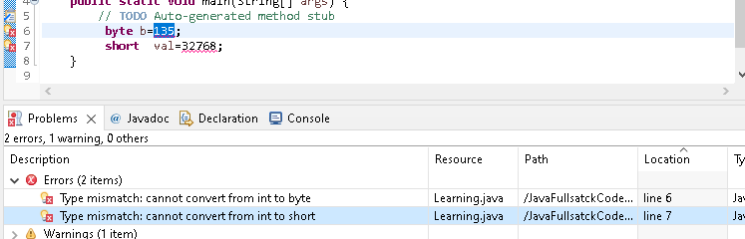

We will prefer the data-type which has capability to large values.

int –Default data-type used for storing integer values
int :

